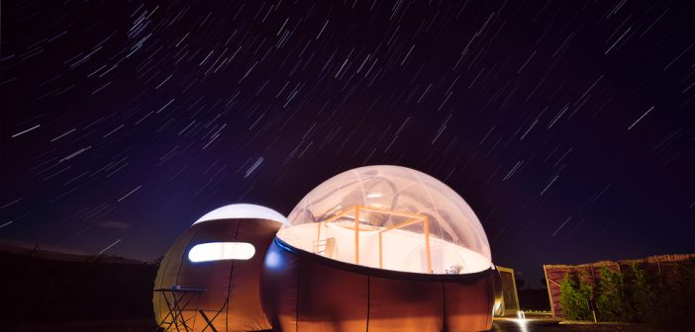

Miluna: a bubble hotel with views of the stars
ON TUESDAY APRIL 2ND, 2019

Only one hour from Madrid, and a few minutes’ drive from the historic city of Toledo in the municipality of Hormigos, lies a touristic project that is truly unique. Miluna Open Nature Rooms opened its doors to the public in September 2018, with bedrooms that tick every box of the “glamping boutique” category.
A futuristic fantasy with all the amenities and comfort of a first-class hotel, found within unique and intimate surroundings. Each private 30m² “moon” comprises a canopied king-size bed and bathtub, in which you can lay back and gaze at the stars, surrounded by a private garden lined with aromatic plants.
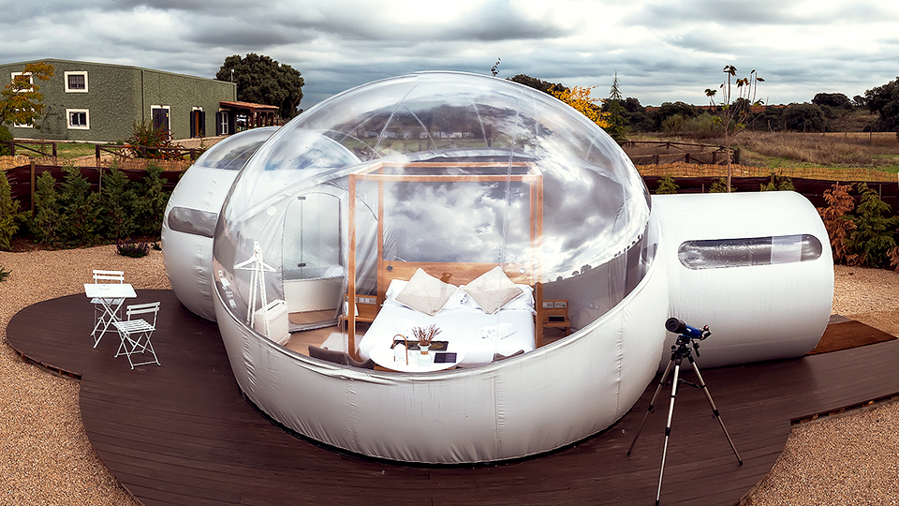

An hotel with four moons
There is a total of four circular bedrooms, each named after a constellation: Callisto, Io, Europa and Ganymede. Also, for guests to enjoy a totally galactic experience, each Miluna bedroom also comes with a lunar calendar, books and a telescope.

Miluna experience
The Miluna experience provides much more than just a night under the stars. The hotel offers various proposals for those who want a break from the hustle and bustle of the city, while reinvigorating themselves through a range of activities. Guests can enjoy a revitalising massage, a unique experience in a zero-gravity flotarium where they will feel like they are wallowing in the Dead Sea, or sample fantastic cuisine in its restaurant offering top-quality, locally-sourced products.
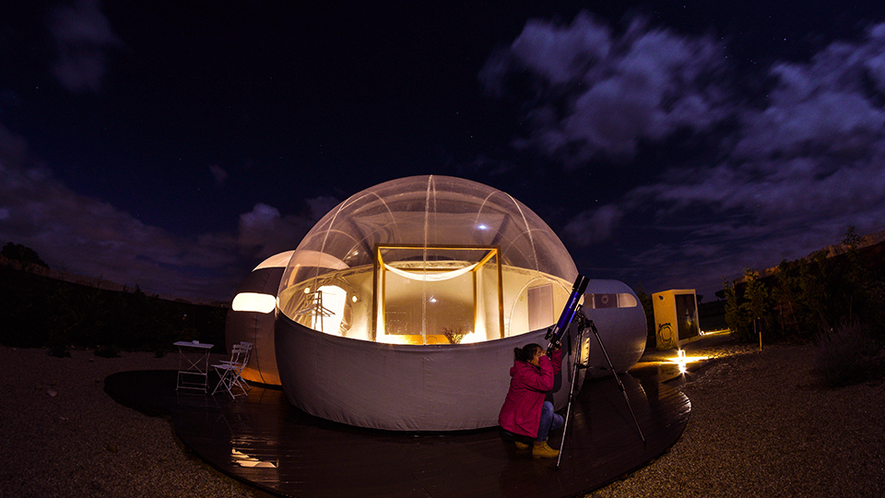
Furthermore, so that guests can see what the local area has to offer, Miluna also organises various activities including bike rides, wine tasting events, horseback rides and sightseeing tours to nearby historic cities.
Offering the best views from a sustainable and environmentally-friendly establishment, Miluna is the latest addition to Spain’s list of accommodation-experience options, with all the ingredients for a magical stay.

